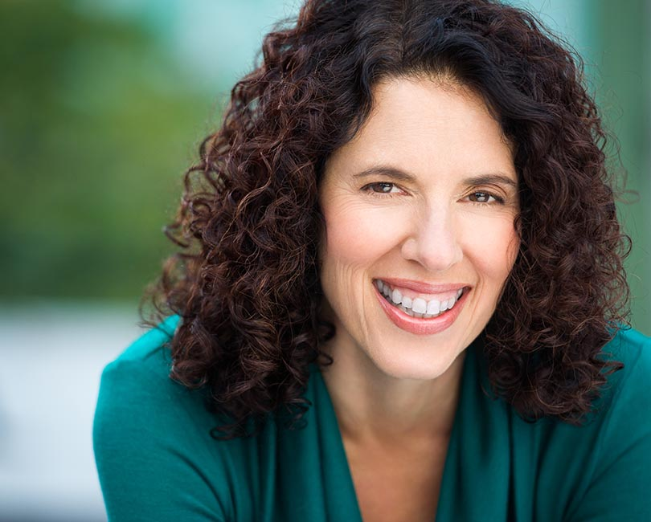
Sheree Wichard
AEA
www.shereewichard.com

OFF-BROADWAY
Can I Help You? Janice Thespis Theater Festival
A Feminine Ending Kim HB Studio
The Lovers’ Lie Mandy Full Moon Playhouse
Dinner with Friends Karen HB Studio
The Bald Soprano Mrs. Smith Absurd Artists Ensemble
Blithe Spirit Madame Arcati HB Studio

REGIONAL THEATER
Lovers & Other Strangers Wilma Arlington Stage Co (VA)
Isn’t It Romantic? Janie Baltimore Players (MD)

FILM
Graft Lorna (ensemble) Simcha Borenstein, Director
At A Crossroad Patricia (female lead) Madhura Berman, Director
Shakira Walks! Veterinarian (supporting) Connor R. McVay, Director

TELEVISION
Green Thumbs Joy (supporting) TV Pilot (in post-production)
Saturday Night Live Overzealous fan NBC
All My Children Nurse Emily ABC
One Life To Live Restaurant goer ABC
Another World Party guest NBC
Ryan’s Hope Nurse Susan ABC

VOICE OVER/AUDIOBOOKS/COMMERCIALS (upon request)

TRAINING
Acting
B.A. in Theater Arts George Washington University
Acting & Interpretation Northwestern University
Acting, Movement and Voice Work London Academy of Music & Dramatic Art
Invitational Studio Practice Michael Beckett, HB Studio (present)
On-camera Intensive Janine Tutillo, Kimball Studio
On-camera Commercial training David Cady; David Bellantoni
Improvisation Peoples Improv Theater
Russian Theater Lab Aleksey Burago, The Russian Arts Theater & Studio
Meisner Technique Richard Edelman, William Esper Studio
Advanced Scene Study Elizabeth Browning, Elizabeth Browning Studio

Voice Over
Commercial VO Roger Becker; Andy Roth; Doriane Elliott; Ed Lewis; Paul Liberti; Marla Kirban
Animation Paul Liberti; workshops with Lori Alan and Everett Oliver
Audiobooks Sean Pratt (privately, nonfiction); Paul Ruben (privately, fiction & nonfiction), Johnny Heller (Splendiferous Narrators’ Workshop)

Skills: Accents (British, Cockney, Southern, Russian, New York/Long Island, character voices, great with
kids and animals

